**USABILITY AND DESIGN OF THE SOLUTION:**

Problem statement:

1. The Receptionist needs a tracking tool that knows to any given time which guests are checked into the hotel and have not checked out, to allow the receptionist to decide whether to accept the parcel or not.
2. The Tracking tool should further allow the receptionist to check for parcels available for pick-up when the guest is checking out.

Usability of the solution: -

4 RESTful JSON-APIs are created in order to support the use case

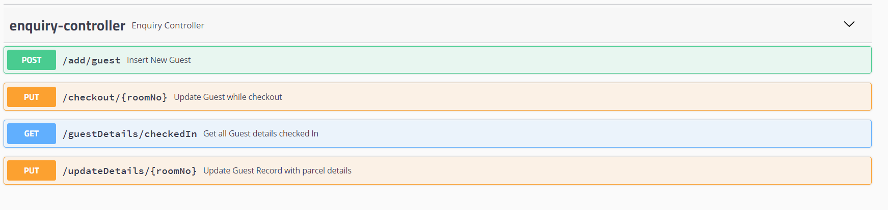

1. **/add/guest**

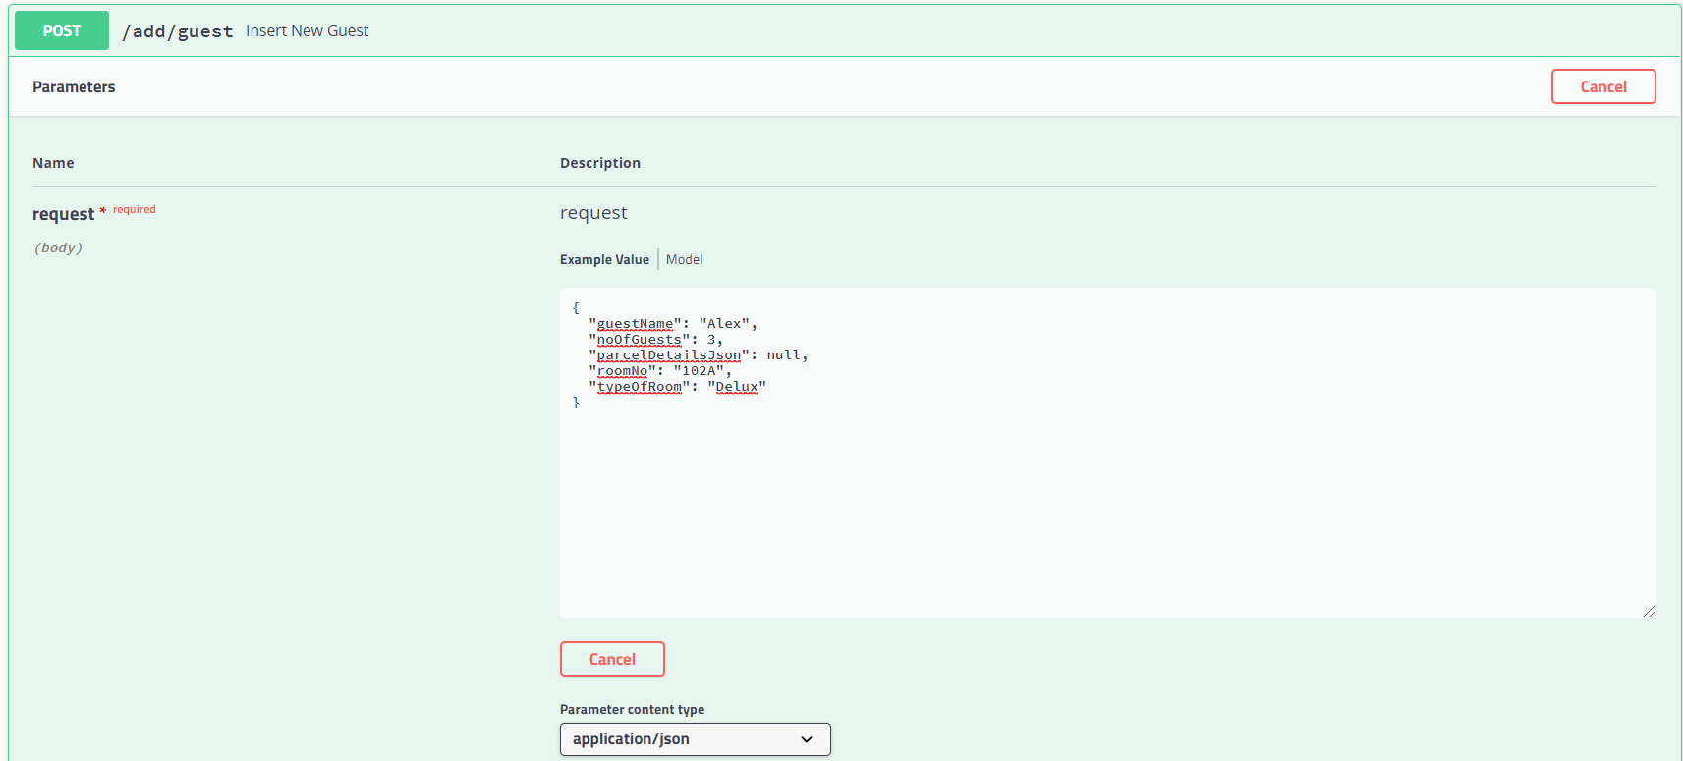

The above end point helps in adding new guests to the Database, when new guests are checked into the hotel it accepts details such as <guestName>, <noOfGuests>, <roomNo> etc and allows to save the information in GUEST_DETAILS table.

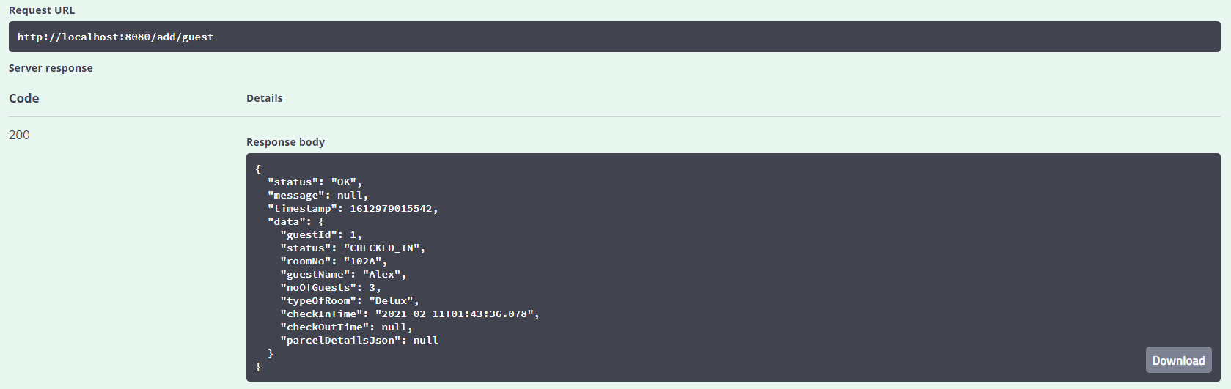

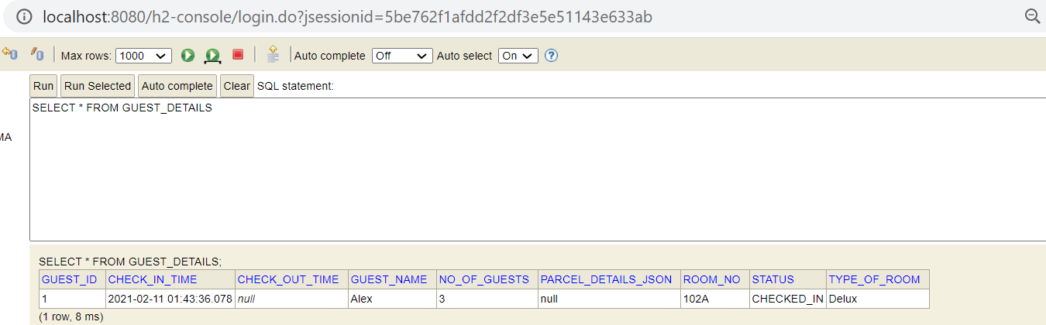

If we try adding other guest with same room, before the guest checks out. We will get the below error

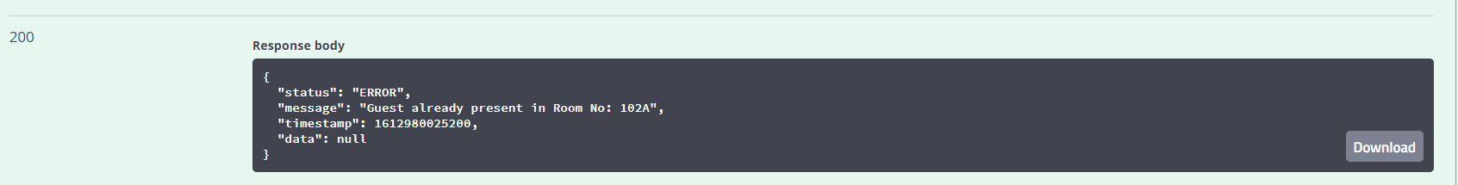

1. **/guestDetails/checkedIn**

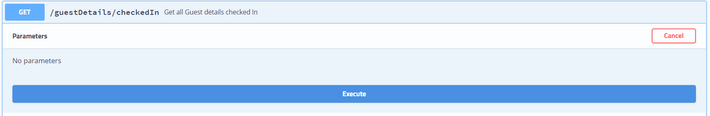

The above end point is added to retrieve the details of checked in guests at any given time, to allow the receptionist to decide whether to accept the parcel or not.

1. **/updateDetails/{roomNo}**

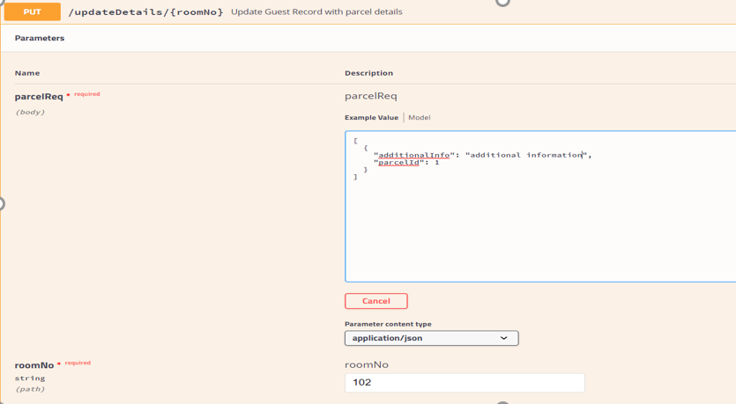

The above end point is added to update the guest details information with parcel details once they receive any parcel.

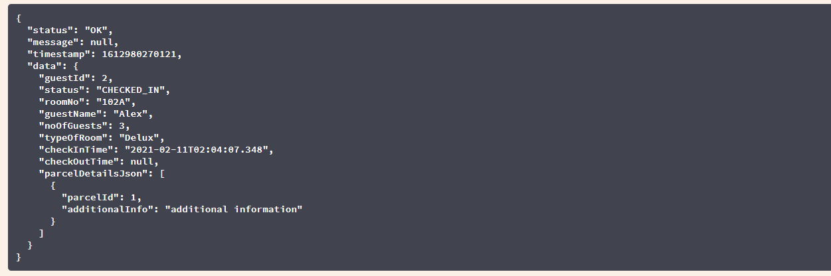



If no guests are present in the room, it shows the below error

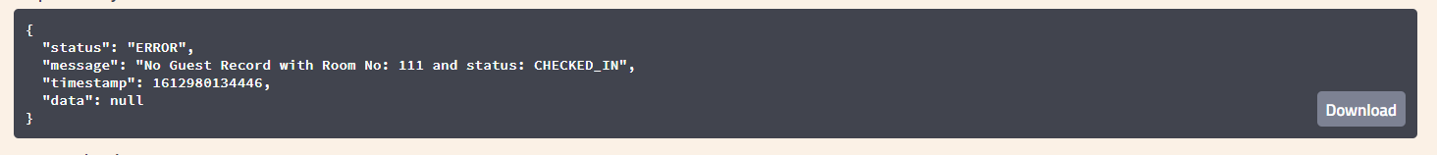

1. **/checkout/{roomNo}**

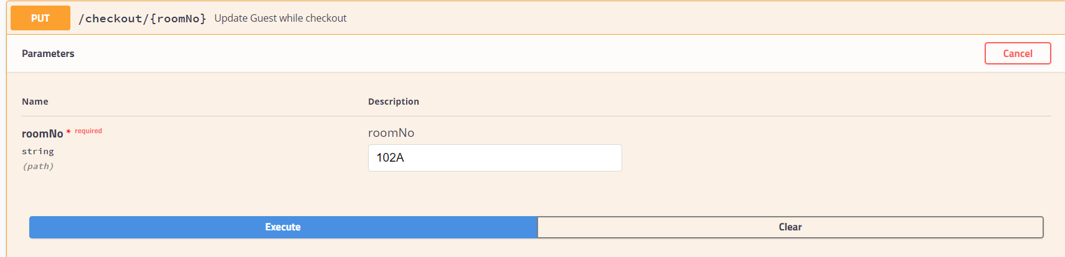

The Above end point is added while the guest checkouts of hotel. It helps to retrieve user information and changes the status to “CHECKED_OUT. This allow the receptionist to check for parcels available for pick-up when the guest is checking out.

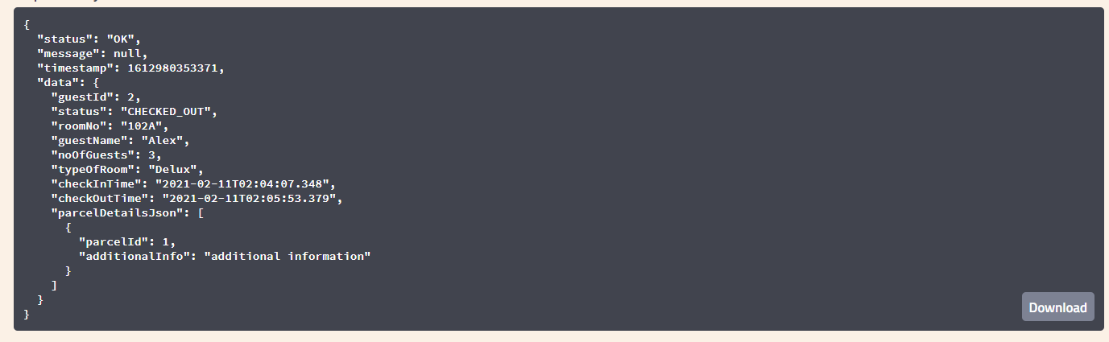



Design Of the solution: